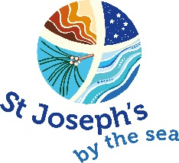
Retreat Application Form

2018

Name: _________________________________________________________________________
Address: _______________________________________________________________________
____________________________________________________Post Code: __________________
Phone: (H) _______________________________ Mobile ________________________________
FAX: (if applicable) _______________________________________________________________
Email: _________________________________________________________________________

THE MYSERY AT THE HEART OF THE  EMERGING UNIVERSE  8th to 15th April, 2018  Cost: $625 All inclusive.  Non-refundable deposit: $75 | BEFRIENDING THE BEAUTY OF YOUR  OWN SOUL  6th to 13th May  Cost: $625 All inclusive.  Non-refundable deposit: $75
A CONTEMPLATIVE JOURNEY  17th to 24th June  Cost: $625 All inclusive.  Non-refundable deposit: $75 | DIRECTED RETREAT  12th to 19th August  Cost: $624 Inclusive.  Non-refundable deposit: $75
THE GARDEN  9th to 16th September  Cost: $625 All inclusive.  Non-refundable deposit: $75 | JESUS THE CHRIST IN ART TODAY  14th to 21st October  Cost: $625 All inclusive.  Non-refundable deposit: $75

Retreat Selection:
Title: ______________________________________________________________________
Dates: _______/_______/2018 to _______/_______/2018
Cost: $__________________

Please return this application form to:
St Joseph’s by The Sea or admin.sjbtsw@sosj.org.au
16 Esplanade
WILLIAMSTOWN VIC 3016

Payments can be made by cheque, cash or via EFTPOS. Please make cheques out to: St Joseph’s By
The Sea.

